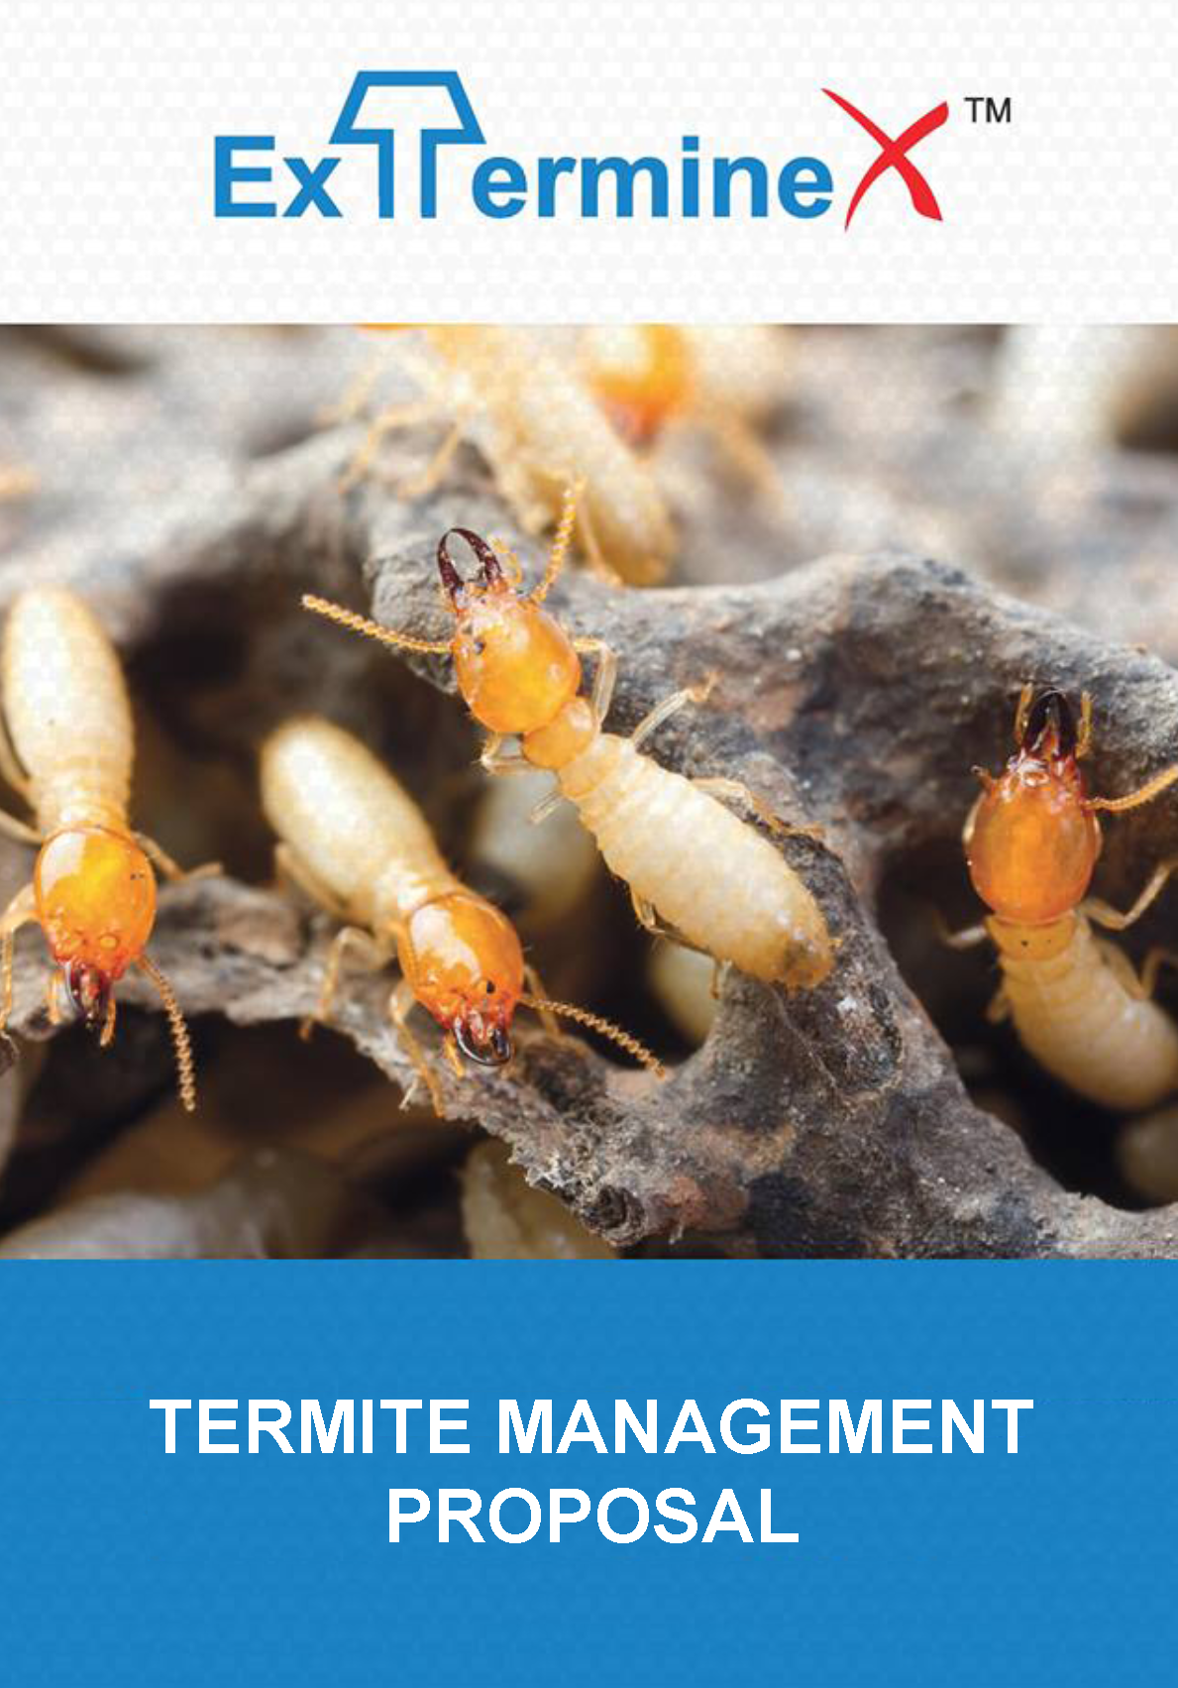

Exterminex ™ Termite Baiting System Proposal
Termite management using Exterminex™ is broken into two stages, Stage 1 or Stage 2 may be proposed separately or as a whole depending on the circumstances the technician has identified during the inspection. No works can be carried out until a termite inspection is complete and a termite management plan is proposed in accordance with current Australian Standards AS3660.2.17.

Stage 1 Colony Control and Inspection
If we have identified live termites in or on the premises. Exterminex™ above ground stations will be installed to live activity in areas where the technician sees suitable.
If this firm is providing an above ground baiting program to live activity inside the property or on the grounds you will notice stations or boxes installed. The technician will install these stations to the live termite activity in your property to encourage feeding on the Exterminex bait contained within these stations.

It is very important to ensure that whilst the termites are feeding on the bait, you as the property owner ensure these stations are not tampered with, moved and as little disruption is carried out around these areas.

The bait contains a small amount of an active constituent that will affect the moulting process leading to eventual colony collapse. The termites will transfer the bait throughout the colony via their unique feeding habits, thus taking time. It is important to be patient during this process, Your technician has been trained to apply this product and once feeding the termites will eventually be eradicated.
The termites prefer the unique Exterminex™ bait over the timber in your property. The length of time to eradicate a termite nest from above ground baiting varies due to factors that include the temperature and season, The colony size and species. Rest assured that by putting in a little time and patience and letting us do the job right we can eradicate this nest that may have caused on going issues if alternative treatments were not affective.
What to expect during the Stage 1 process *Times may vary due to colony size and species.
Day 1 Baits are carefully installed to live termite feeding points after the inspection.
Week 2 Heavy feeding and replacement of baits. It is not uncommon for some baits to get consumed within 5-7 days.
Week 4 Continued feeding, we notice slight changes in the appearance of the soldiers and workers.
Week 6 Feeding has slowed and the worker to soldier ratio has decreased
Week 8 We notice no more worker termites and some boxes are inactive
Week 10 Dead termites in the stations, Mould, mites and no more activity. This can indicate successful colony elimination.
Week 12 A follow up termite inspection shows no activity in the property, Stations removed. Colony elimination achieved.
Stage 2 Management System - Risk Reduction
If the technician has deemed the premises high risk of termite attack or after a stage 1 treatment, In ground stations will be installed to the perimeter of the building in 3 meter intervals.
The Exterminex™ IG In Ground System is an early warning system against termite attack. Small stations are embedded around the building in 3-meter intervals and also in areas where high termite pressure is identified or presumed. These stations are inspected every 6-8 weeks by this firm to intercept foraging termites that will find the stations as a food source.
Your Exterminex termite baiting system will be inspected on a 6 weekly or 2 monthly basis depending on the time of the year and environmental conditions. The in ground stations act as interceptors around your home to identify termite activity and provide a point to apply the Exterminex™ bait.
The technician looks carefully for any signs of live termites in the stations or mud packing as mud packing can indicate activity. Mud will be hard and crumbly forming around the interceptors. The lids are opened as gently as possible.
If termites are active the technician adds the Exterminex™ bait .The termites will feed on this bait until the colony has been eliminated. In some instances this can take months depending on the size of the nest. Rest assured once they have come in contact with the bait they are affected.
The inspector will need to access the property to install termite bait into the active stations generally during routine inspection. Exterminex™ bait is very low toxicity to humans, animals and the environment. The bait consists of natural cellulose, attractants and a small percentage of the active constituent “Chemical”. As termites feed on the bait they are affected over a long period of time, and this is what destroys the colony. The Active Ingredient affects termites by inhibiting certain life cycles that stop the colony from expanding and this effectively obtains colony elimination.
How long does It take to eradicate termites from a station? Depending on the size of the colony it can take 2 - 8 Months. We can identify elimination as the worker cast within the colony changes colour from the effects of the bait and eventually disappears and only the soldier cast is left.
As there are no workers left to feed and support the colony, the nest effectively dies.
What to expect during the process *Times may vary due to colony size and species.
Visit 1 The technician carefully Installs stations around the perimeter into the soil out from the drip line approximately 30cm deep and 8cm wide in 3 meter intervals. This may take longer than 1 day depending on the amount of stations required. If concrete is identified, The in concrete caps and timber are installed using a concrete core drill forming 80mm holes every 3 meters.

Visit 2 First inspection to the system 2 weeks after install. The technician requires external access to check the stations around the structure and will apply the Exterminex Bait if live termites are Identified.

On going Visits If termites are active - The technician will continue to top up the termite bait within the stations every 2 weeks until the termites have been eliminated. Once feeding has stopped, The technician will clean the stations and replace the timbers and If termites are inactive continue to monitor every 6-8 weeks.

Exterminex ™ Termite Baiting System Proposal
Contract/ Job Number:
Installer (EAA):
Technician:
Job Address:
Date:
Client:

Stage 1 - Above Ground Baiting (Live Termites)
Termite Inspection Required:
Above Ground (AG) Stations Required:
Installation / Monitoring / Application:
Additional Notes:
Limitations:

Total Cost Stage 1:

Stage 2 - In Ground (Stations Around The Building)
In Ground (IG) Stations Required:
In Concrete (IC) Stations Required:
Monitoring / Baiting Costs:
Self Monitoring If Applicable:
Limitations:
Additional Notes:

Total Cost Stage 2:

Total Cost Stage 1 & 2

Exterminex ™ General Terms & Conditions

I/we authorise the items accepted and confirm that I/we have read and understand the Terms and Conditions contained within this Agreement.

Signed for and on behalf of: __________________________________________________________________________________
(Name of Client)

By: ______________________________________________________ on this the __________ day of ______________ 20 ______
(Signature)

______________________________________________
(Print the full name of the Client or the person signing for the Client

Pest Controllers Obligations
- The PCO (Pest Control Operator) shall install the agreed system in accordance with the Installation manual, taking reasonable care of the property at all time. Where drilling of concrete is required for the placement of IC Stations, it is the owner's responsibility to accurately indicate the position of any water pipes, drainage pipes, electrical cables, conduits, gas lines, telephone cables and the like. The Owner is responsible for any repairs which might arise due to inadvertent penetration of such items.
- If during the course of the System installation it is found that structural or environmental conditions prevent us performing any installation agreed upon; changes to the System from that proposed may be required.
- The PCO shall monitor the stations within the set time frames and bait active stations.
- The Termite Monitoring & Baiting System Agreement applies only to the control of Subterranean Termites, with the exception of Mastotermes darwiniensis. It does not provide for management, control or protection against any other type of termite or pest(s). In particular will not work against and provides no protection against drywood termites, Family: KALOTERMITIDAE.
- No responsibility is accepted, or warranty implied, for the repair of any termite damage to the property under this Agreement. You expressly waive any claim for and discharge and release your Authorised Operator from responsibility for any termite damage regardless of whether the damage is old damage that occurred before the initial installation date or new damage that occurred after the installation date.
- A standard Subterranean Termite Inspection Report in accord with the guidelines of AS 3660.2.17 Termite management must be undertaken before commencement of any termite control or monitoring to the property with also a termite management plan in place. This inspection and report deals only with the detection, or non-detection of Subterranean Termite Attack and Conditions Conducive to Subterranean Termite Attack discernible at the time of inspection. The terms, conditions, limitations associated with that report equally apply to this contract.

Property Owners Actions
- If upon inspection active termites are found within the structure, it is prudent to have a builder perform a full inspection of your property. The purpose of this inspection and report should be to determine the location and full extent of any existing timber damage and to determine if any structural repairs are required. The property owner must pay the outlay cost as detailed on the above page.
- If the property owner notices any form of termite activity in or around the structure, or there is any breaches of the environment conditions set out below, they must notify the pest controller immediately.
- For the system to work effectively and to minimise the presence of environment conditions attractive to Subterranean Termites the owner agrees to:
- Removing any loose timber and trash and breaking any direct wood to soil contact under the structure or for 350mm around the structure.
- Fixing faulty plumbing, leaks or dampness caused by poor drainage.
- Removing any dead trees and stumps under or adjacent to your property since they are nesting sites for Subterranean Termites.
- Increasing subfloor ventilation to the equivalent of 7,300 mm2 per lineal meter or more.
- Rake garden beds and soil away from the structure to expose weep holes and the edge of concrete slabs to a minimum level of 75mm below the top of the exposed slab edge.
- Replacing untreated timber garden surrounds or retaining walls with termite resistant materials.
- If you know of the use of other termite control agents around your property you must advise us as this may seriously affect termite feeding patterns and the time to colony elimination.
- If these next points are not met this contract may become null and void.
- You must rectify conditions outlined in your termite report.
- You agree to provide complete access to your property and the surrounding grounds on a periodic, regular basis, for any purpose contemplated by or made necessary by this Agreement, including but not limited to inspecting and monitoring Stations. Your failure to allow access when deemed necessary by us may result in termination of this Agreement or additional charges.
- You MUST NOT tamper or interfere with the Termite Baiting and Monitoring System or its components. Tampering may render the System ineffective or significantly delay the time to termite monitoring or colony elimination.
- If stations appear broken, open or damaged, you will contact this firm immediately.

